MACH4METAL

metalworking machinery
Transito 21, 6909 DA Babberich, Netherlands
Tel. + 31 (0)316 – 247123
Fax. + 31 (0)316 - 247956
info@mach4metal.com
www.mach4metal.com
Bank No : 66.52.13.883
IBAN : NL33 INGB 0665 2138 83
BIC : INGBNL2A
VAT : NL 815393635B01

OKUMA MACTURN 30 W

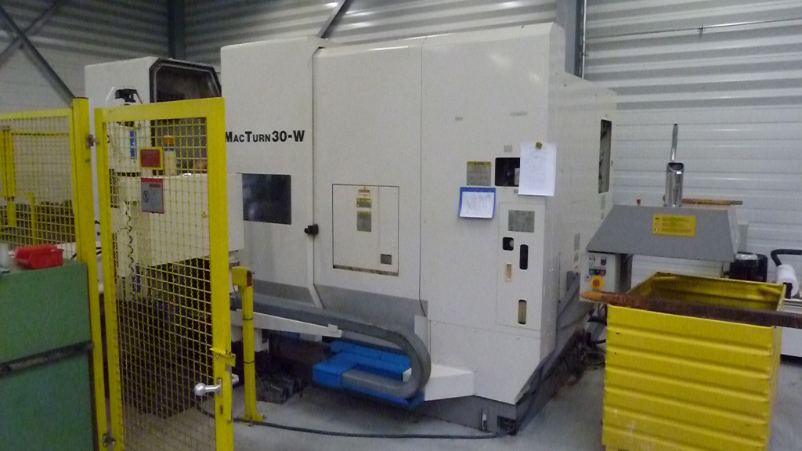
- Make : OKUMA - Japan
- Typ : MACTURN 30 W
- Serial NO : 0241
- Age : 2000

- Capacity
- Swing over bed : 550
- Max. machining Ø : 500
- DBC turning length : 1.500
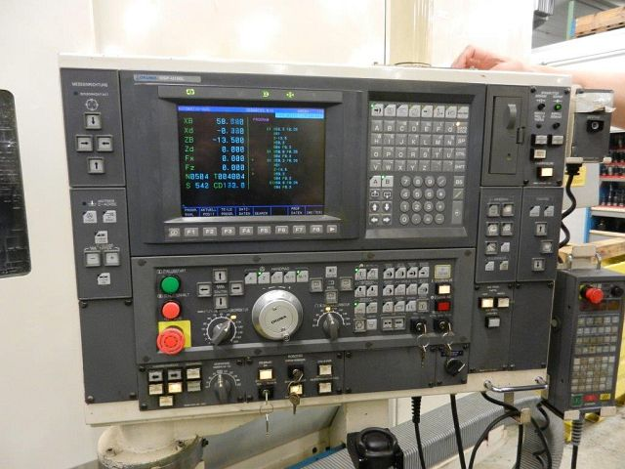

- Main spindle
- Spindle bore : 80
- Power Kw : 22
- Spindle speeds : 3.800
- Torq Nm : 412

- Upper turret
- X travel : 430
- Z travel : 1.590
- Y travel : 190 ( + 95 – 95)
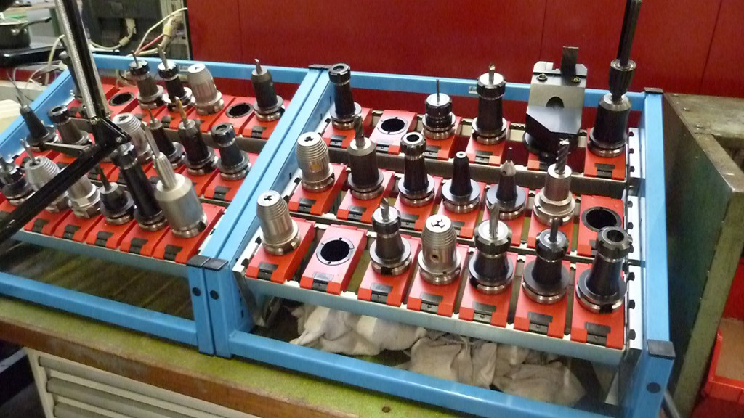
- C travel : 360.000
- B travel : 0.001 Gr

- Turret with 2 positions for mill & turn
- ATC with 40 positions BT 40

- Milling spindle
- Milling spindle : 7 kW
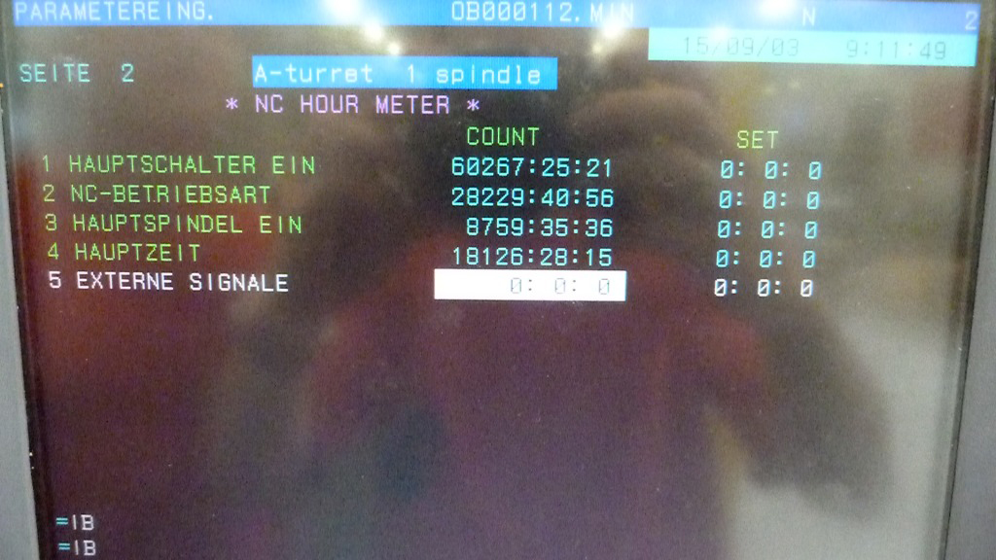
- Spindle speeds : 6.000 Rpm
- Tool shank : Bt 40
- Torque : 50 Nm

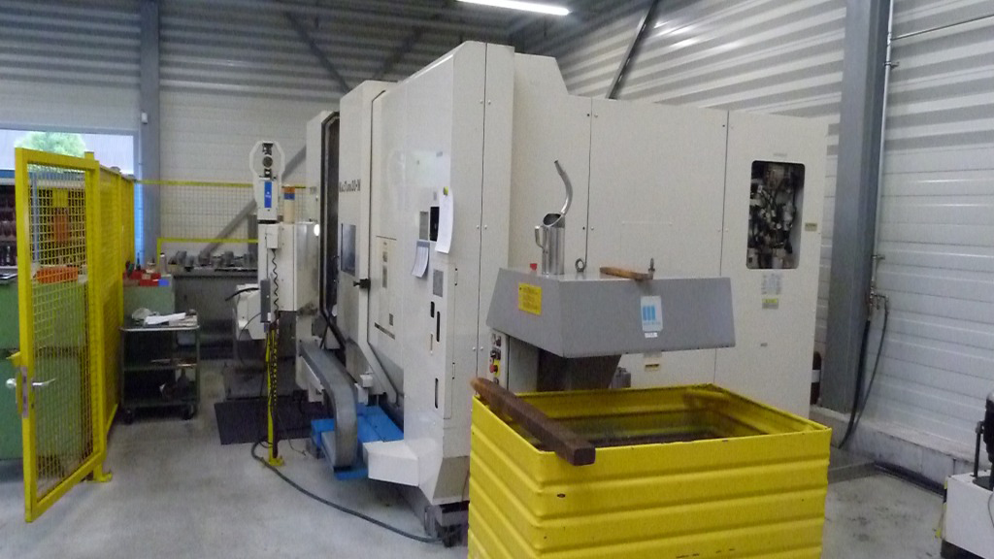
- Sub spindle
- Sub spindle Ø : 80
- Power : 7.5 kW
- Speeds : 6.000 Rpm
- Chuck Ø : 170

- Lower turret
- Lower turret : 8 Positions
- Cutting tool shank : 25 x 25 mm
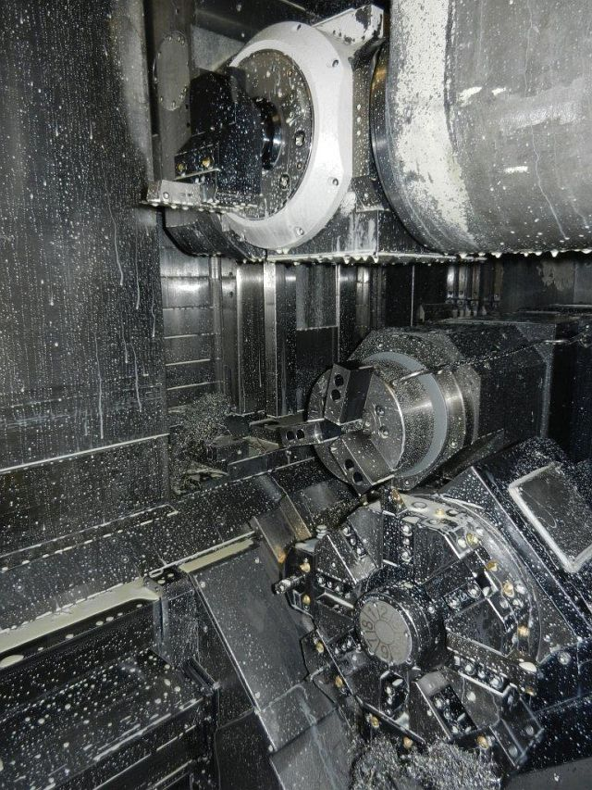

- Dimensions
- Length : 5.200
- Width : 2.500
- Height : 2.300
- Weight : 13.000

- Chip conveyor Mayfran

- OSP – U 100L CNC

- High pressure coolant

- Large tooling package

- OKUMA Loading robot

- Okuma feeding system

Please Note: The above information has been obtained to the best of our ability and belief from, and from the manufacturers where possible. It is given in good faith, but its accuracy can not be guaranteed. Accordingly, it will not form a representation or constitute contractual terms. We advise you to check any vital details!

